Task 3: Explore Coding & Collaboration Platforms

Part A: CODE CHEF

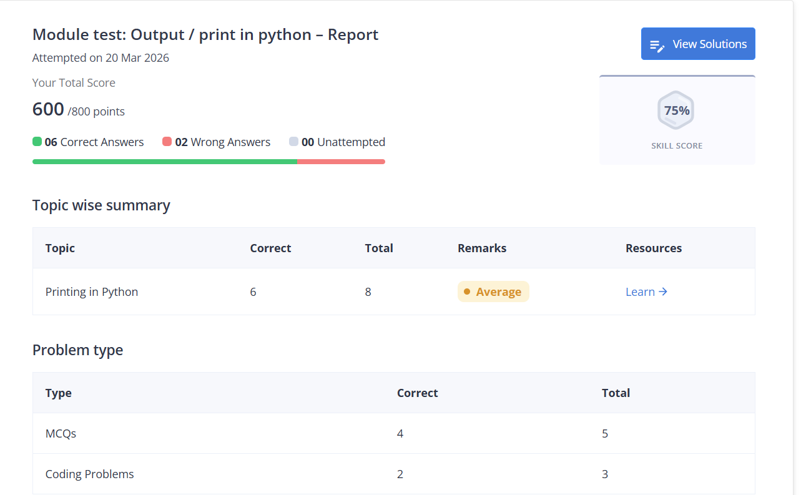
Part B: Google Workspace
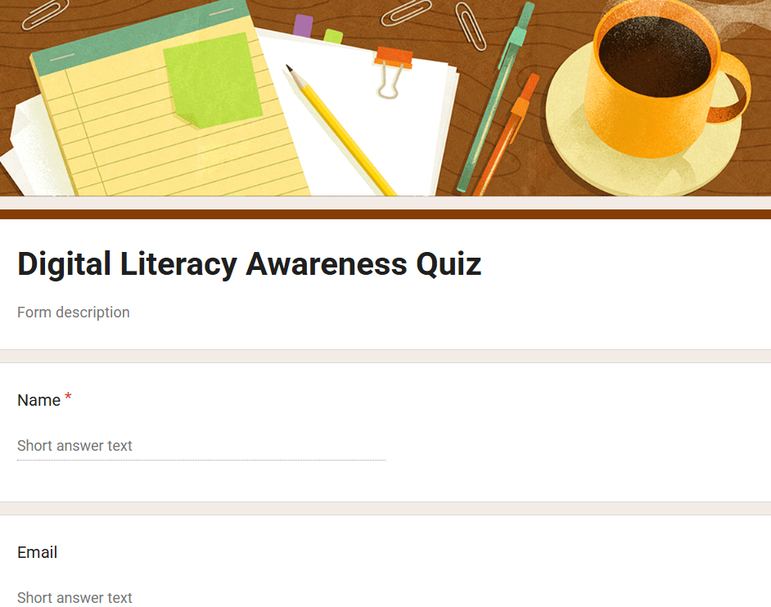
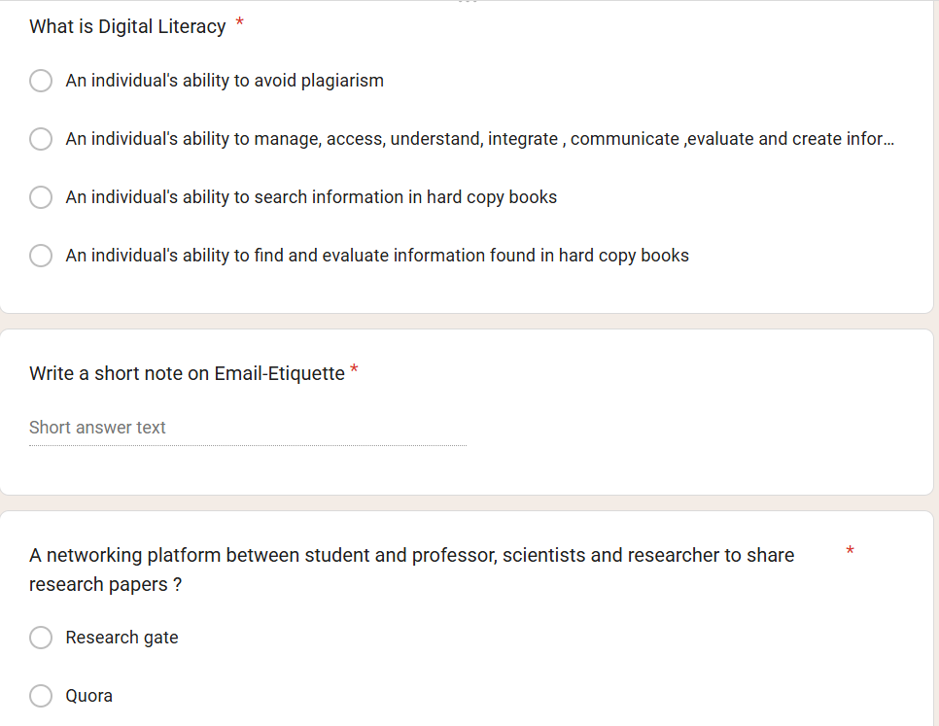
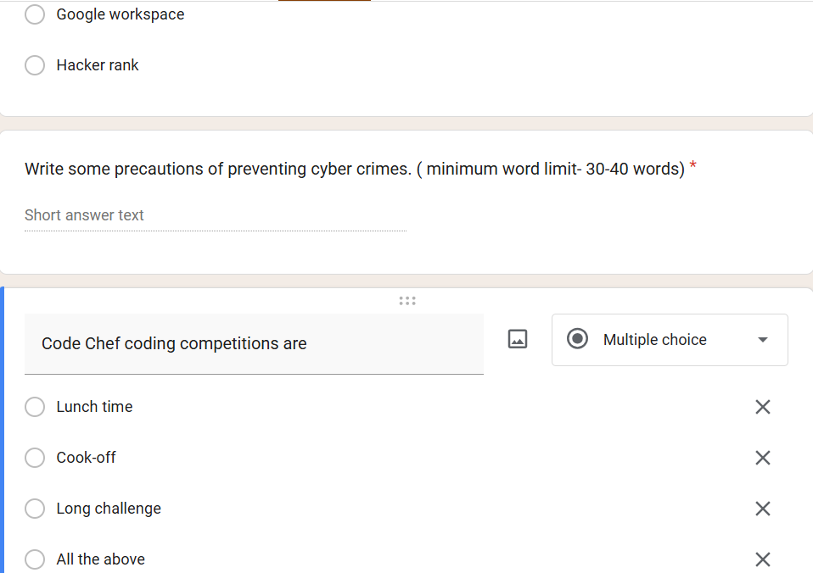

In part -A it was all about using coding platforms/tools to built your coding skills. Is a competitive coding environment created by Unacademy and originally started by Directi. Long challenge, Cook-off and Lunch time are the different stages of coding competitions. I used Code Chef tool in which I was open to learn python language. After attending its online lectures, I practiced its test which includes basic concept of printing the variable, addition of two numbers to making a small program using for / while loop. In academics, this tool is very beneficial as it sharpens your coding skills according to the language you chose. Coding challenges increases your logic and problem solving skills which helps to get the ability to tackle any problem statement.

In part-B, I used Google workplace is a online tool for student, educators, business owner in which g-mail, docs, drive and meet work together in real time from anywhere. It contains google form in which we can design any assessment, voting form, for viewers. It is best for feedback collection and for assignment purposes .I gives option to select variety of customize theme as per the title of the form.
I constructed a Digital Literacy Awareness Quiz which includes 3 multiple chose questions and 2 short answer type. I have selected option of submitting only single response , multiple response accepting option is too available.

